Example: Asynchronous SRAM Read from FPGA

Schematic:

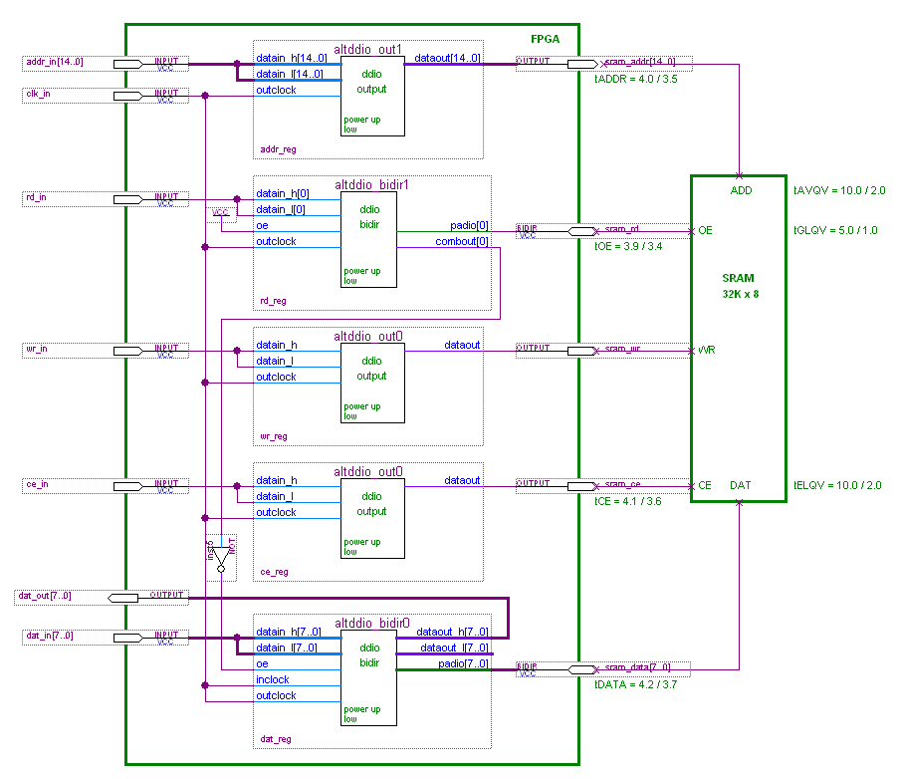

Description:

This is an example (similar to the previous example Simple Fed-Back Data through External Combinatorial Path) of constraining fed-back data. In this example, the data capture path of an asynchronous SRAM access is timed. Only the read path is timed in the interest of focusing on the specific constraints for the fed-back data. The write data path is a source synchronous interface with the sram_wr as the clock and the sram_data is the data to the SRAM. To understand how to constrain the write path, refer to the “Source Synchronous” sub-section of the “Input/Output” section of this document.

As in the previous example, the Data Arrival time to the data capture register (data_reg) involves an external fed-back delay. The external combinatorial delay for the asynchronous SRAM is the data access time from the SRAM address (sram_addr) , or Address Valid to data out (Q) Valid (tAVQV). This is a 15-bit bus instead of a single line as in the previous example. Since the data output is subject to change if any address bit changes, a clock must be created on each address line. The SDC file demonstrates a simple way to do this with a for loop. In addition, the SRAM device will only output data when the chip enable (sram_ce) is asserted. The access time from chip enable valid to data out valid is tELQV. The SRAM device also has an output enable (sram_rd) that must be asserted during a read operation, and has an access time of output enable valid to data out valid (tGLQV). All three conditions; address, chip enable, and output enable are required for a read operation, so all must be timed using the same “trick” as in the previous example by creating a launch clock on the sram_addr[14..0], sram_ce, and the sram_rd lines with separate set_input_delay constraints for each. Since the target is the same for all input constraints (sram_data), the –add_delay option is required on the set_input_delay constraints.

For demonstration purposes, an assumption is made in this example that the chip enable (sram_ce) is asserted one clock cycle before (and one clock cycle after) valid address and output enable. A set_multicycle_path constraint is used to account for the extra clock cycle in the access time from chip enable to handle this.

Note that in this example, the ALTDDIO MegaFunctions are used to generate the registers in this design. Since these are normally used for double data rate, and this interface is single data rate, the high and low data inputs are tied together. The advantages of this approach are that it produces lower skew on the address bus (and control signals), provides the lowest register-to-output and input-to-register times without requiring constraints, and eliminates the need to create an intermediary clock on the output registers. With the ALTDDIO outputs, the critical timing path is the clock used as the mux select in the MegaFunction, therefore the path from the clock input to data output is not considered to go through a timing node. Since the output registers are forced into the I/O cell, it is not necessary to constrain the output with set_output_delay commands to optimize the register-to-output times as in the previous example. (Note however that the outputs will be considered as unconstrained, which would only be an issue if the design is going to HardCopy®). These advantages lead to a somewhat simplified SDC file.

SDC Constraints:

# Input clock
set period 30.0
create_clock [get_ports {clk_in}] \
-name {clk_in} \
-period $period

# Read timing parameters
# Address (ADDR) trace delay from FPGA to SRAM
set tADDR_max 4.0
set tADDR_min 3.5

# ADDR to DATA access time
set tAVQV_max 10.0
set tAVQV_min 2.0

# Chip Enable (CE) trace delay from FPGA to SRAM
set tCE_max 4.1
set tCE_min 3.6

# CE to DATA access time
set tELQV_max 10.0
set tELQV_min 2.0

# Output Enable (OE) trace delay from FPGA to SRAM
set tOE_max 3.9
set tOE_min 3.4

# OE to DATA access time
set tGLQV_max 5.0
set tGLQV_min 1.0

# Data (DATA) trace delay from FPGA to SRAM
set tDATA_max 4.2
set tDATA_min 3.7

# Constrain the read timing with respect to the address bus.
for {set i 0} {$i < 15} {incr i} {
# Create a clock on each output port of the address bus (addr)
create_generated_clock [get_ports “sram_addr[$i]”] \
-name “addr_bit{i}_clk” \
-source [get_ports {clk_in}]

# Constrain the input timing with respect to each address bit.
set_input_delay [expr $tADDR_max + $tAVQV_max + $tDATA_max] \
-max \
-clock [get_clocks “addr_bit{i}_clk”] \
[get_ports { sram_data[*]}]
set_input_delay [expr $tADDR_min + $tAVQV_min + $tDATA_min] \
-min \
-clock [get_clocks “addr_bit{i}_clk”] \
[get_ports { sram_data[*]}]
}

# Constrain the read timing with respect to the output enable (rd)
create_generated_clock [get_ports {sram_rd}] \
-name {rd_clk} \
-source [get_ports {clk_in}]

set_input_delay [expr $tOE_max + $tGLQV_max + $tDATA_max] \
-max \
-clock {rd_clk} \
-add_delay \
[get_ports {sram_data[*]}]
set_input_delay [expr $tOE_min + $tGLQV_min + $tDATA_min] \
-min \
-clock {rd_clk} \
-add_delay \
[get_ports {sram_data[*]}]

# Constrain the read timing with respect to the chip enable (ce)
create_generated_clock [get_ports {sram_ce}] \
-name {ce_clk} \
-source [get_ports {clk_in}]

set_input_delay [expr $tCE_max + $tELQV_max + $tDATA_max] \
-max \
-clock {ce_clk} \
-add_delay \
[get_ports {sram_data[*]}]
set_input_delay [expr $tCE_min + $tELQV_min + $tDATA_min] \
-min \
-clock {ce_clk} \
-add_delay \
[get_ports {sram_data[*]}]

# Assuming that chip enable is active a cycle before output enable
# (rd) and is held a cycle longer than output enable the following
# multicycles are needed.
set_multicycle_path 2 \
-end \
-setup \
-from [get_clocks {ce_clk}] \
-to [get_clocks {clk_in}]

set_multicycle_path 2 \
-end \
-hold \
-from [get_clocks {ce_clk}] \
-to [get_clocks {clk_in}]

Quartus Archive:

